Ultimate Namibia Safari

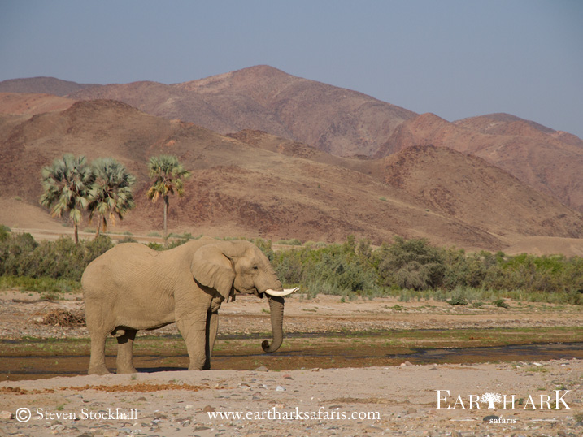
Duration 12 nights

Price per person travelling: USD 4500.00
Single Supplement: USD 400.00

Highlights:
Etosha National Park, Himba Land, Black Rhino Tracking, Landscapes

Destinations:
Windhoek, Etosha National Park, Kaokoland, Epupa Falls, Puros,
Grootberg Mountains, Erongo Mountains

Extension Highlights:
Swakopmund, Sossusvlei, The Namib Desert
Duration 4 nights

Price per person travelling: USD 1715.00
Single Supplement: USD 100.00

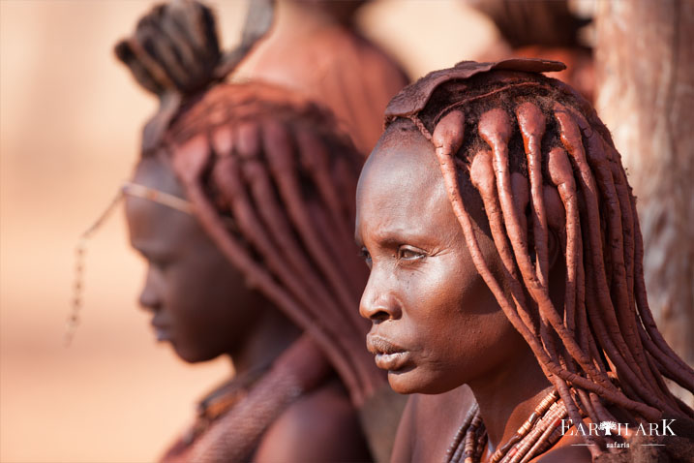
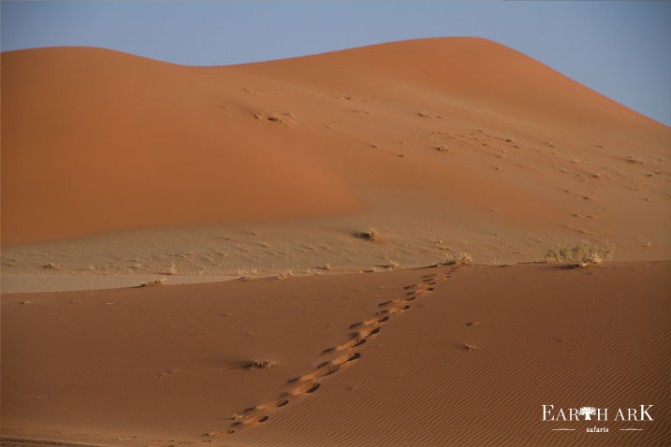
Safari program

Day 1 Arrive in Windhoek, Galton House
Day 2 & 3 Anderssons Camp, Southern boundary of Etosha National Park
Day 4 Hobatare Lodge, Kaokoland
Day 5 & 6 Omarunga Camp, Epupa Falls
Day 7 Etambura Camp, Orupembe
Day 8 & 9 Puros Bush Camp, Puros
Day 10 & 11 Grootberg Lodge, Grootberg Mountains
Day 12 Erongo Wilderness Lodge, Erongo Region
Day 13 Departure from Windhoek International Airport

SOSSUSVLEI EXTENSION: Extra Fees apply
Day 13 Cornerstone Guesthouse, Swakopmund
Day 14 & 15 Hoodia Desert Lodge, Namib Naukluft National Park
Day 16 Galton House, Windhoek
Day 17 Departure from Windhoek International Airport

Meal Key - B = Breakfast L = Lunch D = Dinner

Destination:

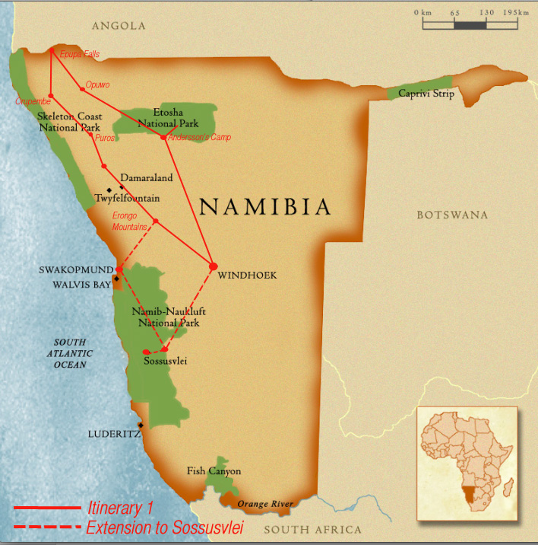
Namibia is a vast country, even by African standards, covering an area approximately four times the size of the United Kingdom but with a population of a mere 2 million - one of the lowest densities in the world. It is also an 'ageless land’; visible through our heritage of rock art created by stone-age artists and geological attractions such as the petrified forest where fossilised tree trunks have lain for over 280 million years. Added to the space and silence, these all contribute to a feeling of antiquity, solitude and wilderness.

The climate is typical of a semi-desert country. Days are warm to hot and nights are generally cool. Temperatures are modified by the high plateau in the interior and by the cold Benguela Current that runs along the Atlantic coastline. Except for the first few months of the year, the country is generally dry with very little rain.

This privately guided Namibian safari affords you the chance to experience this magnificent and memorable country in a very personal way. You will have your own professional and experienced safari guide who will enhance your enjoyment of this unique country by making it a fascinating and stress-free journey of discovery amidst very dramatic scenery. The knowledge, experience and attitude of our guides are critical to a successful safari which is why we ensure that they are both personable and very professional.
Journey Map

Your Ultimate Safaris guide will have an intimate knowledge of each area and camp/lodge that you visit, allowing them to share the local highlights whilst adding continuity and depth to your safari. It goes without saying that they know exactly what a "True African Safari" is all about. Not only are our guides highly qualified, each has a specific area of expertise. Together they possess the breadth and depth of knowledge to allow them to answer questions and satisfy the particular interests of each of our guests. Your Ultimate Safaris guide will turn your safari into an experience of a lifetime!

DAY 1: Windhoek, Namibia: 1 Night – Galton House D
After landing at Windhoek’s International Hosea Kutako Airport, you will be welcomed by an Ultimate Safaris representative who will transfer you to Galton House where you will stay your first night in Namibia. You will be treated to a short city tour of Windhoek en route. After your arrival at the guesthouse you will have time to settle into your room before dinner. Dinner tonight can be enjoyed at the guesthouse or out in town at one of Windhoek’s famous restaurants with your Ultimate Safaris guide who will discuss the details of your safari with you.

Windhoek Capital City: Windhoek, Namibia’s capital nestles among rolling hills, bounded by the Eros Mountains in the east, the Auas Mountains to the south and the Khomas Hochland in the west. It is a meeting place between Africa and Europe, the modern and the old. In the capital’s main street, well-preserved German colonial buildings are in sharp contrast with modern architectural styles, while Herero women in their traditional Victorian dresses mingle with executives dressed in the latest fashions. Located centrally, Windhoek is the starting point of an adventures holiday for many visitors to the country and an ideal base from where to explore the rest of the country. The city’s restaurants offer a variety of meals, ranging from international and continental cuisine to German dishes such as Eisbein with Sauerkraut and African delicacies such as Mopane worms. Windhoek offers a wide choice of accommodation options, ranging from four-star hotels and homely pensions to backpackers establishments and campsites. In the rural areas beyond the city’s limits there are also a number of lodges and guest farms.

Accommodation
Galton House: Galton House is Windhoek’s newest accommodation establishment. Named after the famous explorer Sir Francis Galton, it has a relaxed but efficient style which creates a very welcoming atmosphere. A mere ten minute drive from the centre of town and perched on the edge of Windhoek’s northernmost affluent suburb of Eros, guests staying here will be ensured of peace and tranquility. The seven rooms are all equipped with internet connectivity, satellite television, coffee/tea station and general guest amenities. The communal areas consist of a large lounge, dining room, swimming pool and garden. There is also delightful ‘al fresco’ dining area by the pool, serving freshly prepared and very tasty meals. There are also a number shops, restaurants and supermarkets within easy striking distance.

www.galtonhouse.com

Day2: Early breakfast Transfer to Southern Etosha National Park
DAY 2: Southern Boundary of Etosha National Park: 2 Nights – Andersson’s Camp BLD

This morning your guide will collect you at the guesthouse and you then depart Windhoek in your safari vehicle and make your way to Etosha National Park. You have the option to stop off at Okahandja craft market en-route and then you continue to Andersson’s Camp via Otjiwarongo and Outjo. Afternoon game drive with your guide within the Park and return to camp by sunset.

Accommodation
Andersson’s Camp: Located just 4.5 km from Etosha National Park’s Andersson Gate, Andersson's Camp takes its name from Charles Andersson, the Swedish explorer who first 'discovered' the Etosha Pan with Sir Francis Galton in 1851. Set against a backdrop of the low Ondundozonanandana Mountains, Andersson's Camp is located within the private Ongava Game Reserve which borders onto Etosha National Park. The Ongava Game Reserve is typified by white calcrete soils, rocky outcrops and scrub-covered plains which support a rich variety of game such as giraffe, lion, rhino and various antelope species.

The Camp overlooks a waterhole where guests can enjoy the interaction of wildlife coming and going throughout the day and night. This former farmstead has been tastefully rebuilt to modern-day standards. The design and construction of Andersson’s Camp was guided primarily by the principles of environmental sustainability – reduce, reuse, recycle. The old farmhouse now forms the main dining, bar and swimming pool area of Andersson's Camp, with guest tents radiating outwards into the secluded Mopane woodlands typical of the region. Tents are constructed using a clever mix of calcrete stone cladding, canvas and wood, with double-door entrances and a small verandah that is an extension of the elevated wooden decks on which the tents are raised.

The open-air en-suite bathrooms continue the unique design. Andersson's Camp's close proximity to Etosha National Park is ideal for game drive excursions into Etosha to take in the array of game found there.

www.wilderness-safaris.com

Day 3: Visit Etosha National Park

DAY 3: Etosha National Park

Today you will be treated to an exciting morning guided game drive into the Etosha National Park, returning to Camp for a late lunch and time to relax by the refreshing swimming pool before you head out for an afternoon game drive again.

Etosha National Park: Etosha National Park covers 22,270 km², of which approximately 5,000 km² is made up of saline depressions or ‘pans’. The largest of these pans, the Etosha Pan, can be classified as a saline desert in its own right. The Etosha Pan lies in the Owambo Basin, on the north-western edge of the Namibian Kalahari Desert. Until three million years ago it formed part of a huge, shallow lake that was reduced to a complex of salt pans when the major river that fed it, the Kunene, changed course and began to flow to the Atlantic instead. If the lake existed today, it would be the third largest in the world. Etosha is the largest of the pans at 4,760 km² in extent. It is nowadays filled with water only when sufficient rain falls to the north in Angola, inducing floods to flow southward along the Cuvelai drainage system.

The Park consists of grassland, woodland and savannah. Game-viewing centers around the numerous springs and waterholes where several different species can often be seen at one time. The Park boasts some 114 mammal and over 340 bird species. Wildlife that one might see includes elephant, lion, giraffe, blue wildebeest, eland, kudu, gemsbok (oryx), zebra, rhino, cheetah, leopard, hyena, honey badger and warthog, as well as the endemic black faced impala.

Day4: After breakfast transfer to Hobatare Area (Western Etosha National Park)

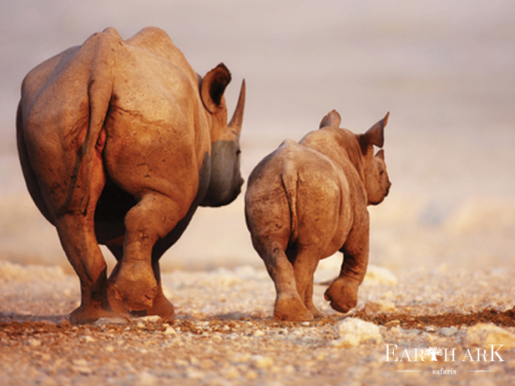

DAY 4: Opuwo Area : 1 Night – Hobatare Lodge BLD

Today is spent game viewing in the Etosha National Park from our private safari vehicles. You enter the park through the southern Andersson Gate and game drive your way west, stopping at selected waterholes to observe the game gathered there along the way, before leaving the park through the western Galton Gate (Otjovasandu) before it closes at sunset. After you have excited the park you will make your way to Uukwaluudi Safari Lodge where you will overnight. Arrival at the lodge will be in the late afternoon with time to freshen up before dinner.

Elephant roam the conservancy but do not enter the reserve. Black Rhino, black-faced impala, kudu, duiker, hartebeest, eland, zebra, giraffe and springbok can be observed. Knowledgeable and experienced guides are present on all excursions. Activities are conducted in specialized game viewing vehicles or on foot while there are no resident predators in the reserve caution is taken due to the presence of rhino. Self-drive 4x4 vehicles are recommended to reach the lodge in the rainy season.

Accommodation
Hobatere Lodge: Hobatere Lodge is situated 65km north of Kamanjab on the western border of the Etosha National Park. Wildlife on the 8,808 ha concession area is home to a wide selection of game including elephant, giraffe, eland and Hartmann’s zebra and many more. Guests stay 12 en-suite rooms and wholesome meals can be enjoyed on the verandah allowing for viewing of the waterhole. The facilities include a lounge, bar, curio shop, and a swimming pool. Hobatere offers guided walk and game drives with an experienced naturalist. The reserve is recognized as the best site in Namibia for endemic birds.

www.hobatere-lodge.com

Day 5: After breakfast transfer to Epupa Falls

DAY 5: Epupa Falls: 2 Nights – Omarunga Camp BLD

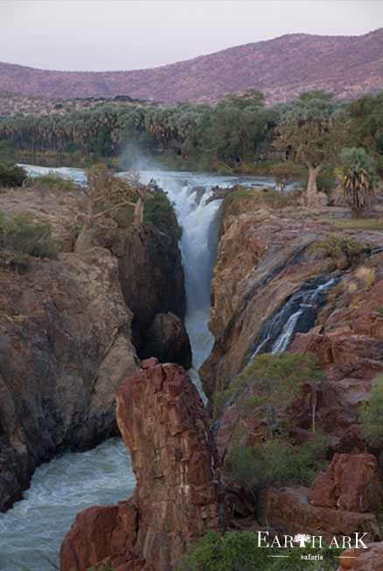
Today after breakfast you will depart to Omurunga Camp. The drive is extremely scenic and you pass a number of settlements along the way. You will also pass through the capital of Kaokoveld, Opuwo, which allows you real insight into what local life is like. Lunch will be had en route and arrival at camp is in the afternoon. Enjoy a sundowner overlooking the amazing Epupa Falls.

Epupa Falls: With its scenically beautiful surroundings, Epupa Falls (Herero for ‘Falling Waters’) is one of Namibia’s more remote tourist destinations. The falls are a series of cascades where the Kunene River drops a total of 60 m over a distance of about 1.5 km, (the greatest single drop of 37 m is commonly identified as the Epupa Falls) dividing into a multitude of channels and forming a myriad of rock pools. It is possible to swim in these pools, but stay well away from the lip of the falls and keep a lookout for crocodiles! With its richly coloured rock walls, variety of trees including wild fig, baobabs and waving makalani palms, spectacular sunsets and perennially flowing waters, Epupa Falls offers much to see, do and experience. Bird watching is rewarding, especially for the rare rufous tailed palm thrush, as well as bee eaters, the African fish eagle, kingfishers ranging from giant to the tiny malachite kingfisher, rosy faced lovebirds, paradise flycatchers, louries, bulbuls, hornbills and rollers. Scattered settlements of Himba are another interesting feature of the area.

Accommodation

Omarunga Camp: On the banks of the perennial Kunene River, only a short distance upstream from the spectacular Epupa Falls lies Omarunga Camp. Shaded by exotic Makalani palm trees, this little paradise is one of Namibia’s most remote and secluded getaways. You will be tempted to relax and absorb the striking scenery of the mountains on the Angola side of the river, learn more about the fascinating culture of the statuesque Himba people, and enjoy bird watching and various walking trails along the edge of the river and falls. Omarunga Camp provides charming accommodation in comfortable en-suite thatched chalets with canvas walls, spaced along the bank of the river. A thatched restaurant and bar, curio shop and swimming pool complete the facilities.

www.natron.net/omarunga-camp/main.html

Day 6: Epupa Falls to visit a local Himba settlement

DAY 6: Himbaland

Today after breakfast your guide will take you to visit a local Himba settlement – you may have to search for a while as the semi-nomadic Himba people sometimes move location with no notice. They are one of the last most traditional peoples of Namibia and have little time for conventional practices. You will learn about the customs and traditions of this very proud nation, and will be given insight into their beliefs, way of life and everyday routine. Return to camp for an afternoon at leisure or explore the falls further.

The Himba: The Himba, Tjimba and other Herero people who inhabit Namibia’s remote north-western Kunene Region are loosely referred to as the Kaokovelders. Basically Herero in terms of origin, language and culture, they are semi-nomadic pastoralists who tend to tend from one watering place to another.

They seldom leave their home areas and maintain, even in their own, on which other cultures have made little impression. For many centuries they have lived a relatively isolated existence and were not involved to any noteworthy extent in the long struggle for pasturelands between the Nama and the Herero.

The largest group of Kaokovelders is the Himba, semi-nomads who live in scattered settlements throughout the Kunene Region. They are a tall, slender and statuesque people, characterized especially by their proud yet friendly bearing. The women especially are noted for their unusual sculptural beauty, enhanced by intricate hairstyles and traditional adornments. They rub their bodies with red ochre and fat, a treatment that protects their skins against the harsh desert climate.

The homes of the Himba of Kaokoland are simple, cone-shaped structures of saplings, bound together with palm leaves and plastered with mud and dung. The men build the structures, while the women mix the clay and do the plastering. A fire burns in the headman’s hut day and night, to keep away insects and provide light and heating. A family may move from one home to another several times a year to seek grazing for their goats and cattle. Men, women and children wear body adornments made from iron and shell beads. A Himba woman spends as much as three hours a day on her toilette.

First she bathes, then she anoints herself with her own individually prepared mixture which not only protects her skin from the harsh desert sun, but also keeps insects away and prevents her body hair from falling out. She uses another mixture of butter fat, fresh herbs and black coals to rub on her hair, and ‘steams’ her clothes regularly over the permanent fire.
Men, women and children adorn themselves with necklaces, bracelets, anklets and belts made from iron and shell beads. With their unusual and striking designs, these items have gained a commercial value and are being produced on a small scale for the urban market. Sculptural headrests in particular are sought-after items.

Return to your lodge

Day 7: Transfer to Orupembe

DAY 7: Orupembe: 1 Night – Etambura Camp BLD
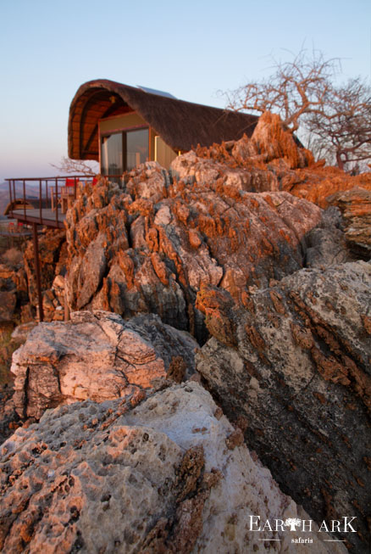
Today you make your way south to Etambura Camp situated close to Orupembe. You can enjoy the scenery along the way until you reach the camp. Lunch will be taken en-route today at a scenic location, arriving at the stunningly located Etambura Camp in the mid afternoon. The rest of the afternoon can be spent visiting an old marble mine and the surrounding area, or just spend the afternoon enjoying the views from the camp. You guide today will become your chef, preparing dinner on an open fire.

Accommodation
Etambura Camp: Etambura, Namibia’s first Himba co-owned camp is situated in Orupembe Conservancy on top of one of the highest hills above the holy plains of Onjuva where livestock and springbok peacefully graze together. The holy plains are steeped in mystery, with several different stories of why the area was consecrated by the semi-nomadic Himba herders who live here. But one thing is sure, hunting is strictly forbidden. Tradition has it that animals on the plains are protected by the ancestral spirits.

Etambura is the ideal place to relax. You might see a klipspringer or at dusk, a Jameson’s rock rabbit. Tiny footprints are evidence of genets and African wildcats. The calls of a diversity of birds, the whispery rustle of paper-bark and other commiphora trees, bottle trees in bloom, the rich hues of purple-pod terminalia with unimpeded 360 degree views make this unique spot unforgettable. After a game drive where you might be fortunate enough to see black rhino, enjoy a stroll and explore the hill, a botanical treasure trove with its many endemic species of plants and shrubs.

Etambura has five canvas and thatch chalets (one of which is wheelchair friendly), each with its own private deck extending from the hill and into the beyond, conjuring illusions of “stepping into air”. The twin bedded rooms are comfortably furnished and provide a wonderful retreat. Each bathroom, built either into the surrounding marble outcrops, or artfully created so as not to encroach on the endemic flora, has its own charm. Bed linen and towels are provided. Built on a wooden platform and, in some cases, on stilts, each unit is positioned to optimize the view. Lie in bed and be dazzled by an incredible sunrise. At night follow the path of the stars across a cobalt sky. Observe the skittish rock hyraxes sunning themselves on jagged rocks, listen to the calls and discover a world of birds that thrive in this environment.

www.kcs-namibia.com.na/etambura.html

Day 8: After breakfast transfer from Orupembe to Puros

DAY 8 & 9: Puros: 2 nights – Puros Bush Camp BLD
Today you head further south to Puros where you will be staying at Puros Bush Camp for the next two nights. This bush camp is extremely basis and run by the local community, so be prepared for an authentic experience. Again, your guide will turn to chef, preparing all your meals. The afternoon is spent on a nature drive in the area with your guide before return to the camp for a sundowner and to settle in for dinner and overnight. The next day is spent exploring the area, famous for its magnificent scenery in search for desert adapted elephants and lions.
Accommodation
Puros Community Campsite: Puros Community Campsite is located on the banks of the ephemeral Hoarusib River under the shade of towering Ana and Camelthorn trees. Wildlife roams freely in this area including desert adapted elephant, giraffe, springbok, ostrich and lion. Birdlife is prolific along the vegetated river valley and a morning chorus of red-billed francolins, grey go-away birds, Monteiro’s hornbills and Crimson-breasted shrikes welcomes each day. This well maintained campsite provides ablution facilities with running water and flush loos as well as BBQ areas, and a reception

Day 10: After breakfast transfer to Grootberg

DAY 10: Grootberg: 1 Night – Grootberg Lodge BLD

After breakfast you will take the scenic drive south into the heart of Damaraland; traveling to the Hoanib River and then following this to Sesfontein. This areas is home to a fair bit of desert adapted wildlife and normally makes for some spectacular drives. You arrive at Grootberg Lodge in the late afternoon. Grootberg Lodge is the only wholly owned community lodge in Namibia, and is an example of changing times when it comes to business ownership.

Accommodation
Grootberg Lodge: Perched on the rim of the Grootberg Plateau, Grootberg Lodge offers unsurpassed views over the Klip River Valley below. Each of the charming en-suite rock and thatch chalets gaze out over the gorge, where black eagles hunt just below the level of your private deck. The lodge’s main area with restaurant, bar and swimming pool are also designed to maximize the stunning views. Grootberg Lodge is a landmark in Namibia for the tourism industry as it is the first middle-market establishment in the country that is 100% owned by the conservancy. 12,000 hectares have been set aside by the local #Khoadi //Hoas community for conservation and tourism.

The European Union funded the project through the Ministry of Environment and Tourism’s Development Programme with a donation of N$4.5 million to develop the 12 room lodge. The private sector was also called in to supply the training and management skills until the community becomes self-sustainable. This pristine wilderness can be explored either on foot or by vehicle to encounter the inhabitants of this remote biosphere. Desert adapted elephant, black rhino, giraffe, kudu, oryx and lion are just some of the animals that roam this area.

www.grootberg.com

Day 11

Today after breakfast you will embark on an exciting activity which is really not for the faint hearted. With a local guide from the lodge today you will be treated to a rhino tracking activity into the local area. The guide, along with the game trackers, will take you in an open 4x4 game vehicle down to the Klip River. Part of the tracking will take place on foot, with the possibility of between 1 to 3 hours walk at the most. At lunchtime there will be a stop near the springs where people can enjoy some refreshments. It is almost a full day activity. Sightings are not always guaranteed because Damaraland is one of the last places on earth where animals roam free.

Day 12: After breakfast transfer to Erongo Mountains
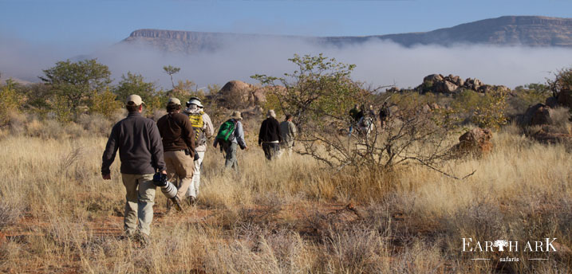

DAY 12: Erongo Mountains: 1 Night – Erongo Wilderness Lodge BLD

After breakfast you depart and head even further south to the Erongo Mountains near Omaruru. We aim to arrive at Erongo Wilderness Lodge in the early afternoon and stay here for one night. This afternoon you may like to join a guided sundowner walk to a breathtaking viewpoint nearby the Lodge. Return to the lodge with time to freshen up before dinner is served.

Accommodation
Erongo Wilderness Lodge & Conservancy: Erongo Wilderness Lodge is nestled amid granite formations on the outskirts of an ancient volcano which was last active around 150 million years ago. These are the Erongo Mountains – a spectacular feature that rises imposingly out of the surrounding plains. The mountains form a rare confluence of ecosystems that give rise to remarkable biodiversity, including a vast array of plant, reptile, mammal and bird species that are endemic to Namibia. The Lodge is a founder member of The Erongo Mountain Nature Conservancy, joining 30 private landowners in a collective effort to conserve and protect this natural treasure of over 200 000ha in extent. The Conservancy’s mission includes the preservation of the rich cultural heritage in the form of rock paintings and engravings that are found throughout the area, such as at the Paula’s Cave rock art site. The stunning Erongo Mountains are circled by impressive granite outcrops, magnificent rock formations and attractive vegetation. Accommodation at Erongo Wilderness Lodge is in lovely spacious en-suite tents, built on wooden platforms with private balconies overlooking the surrounding rocks and distant plains. Wood and stone walkways lead up to a welcoming thatched main area with restaurant and bar. There is also a refreshing swimming pool and deck where you can relax and soak in the sounds of the birds and rock hyrax (dassies) that shelter in the rock crevices.
.

www.erongowilderness-namibia.com

Day 13: Return to Windhoek for your flight home

DAY 13: Windhoek B

This morning, after freshening up, you will depart for Windhoek in the late morning, via the town of Okahandja, to arrive back at roughly 14h00. Upon your arrival into Windhoek you will be transferred to Windhoek International Airport to check in for your ongoing flight.

This is officially the end of your Namibian Safari. We hope to see you again soon, Bon voyage…!

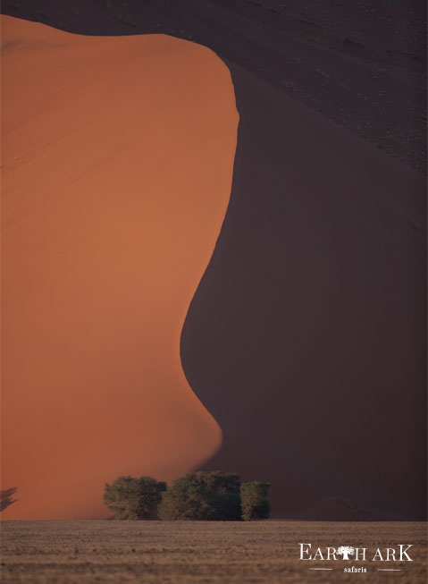
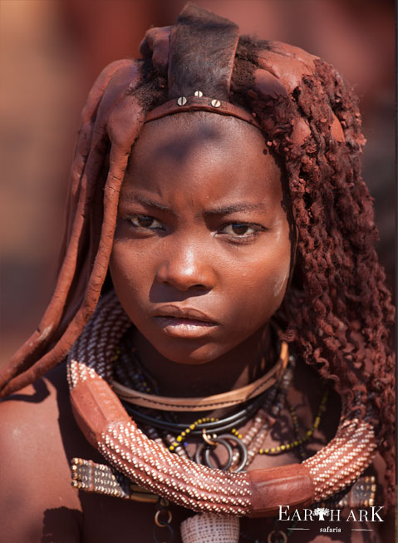
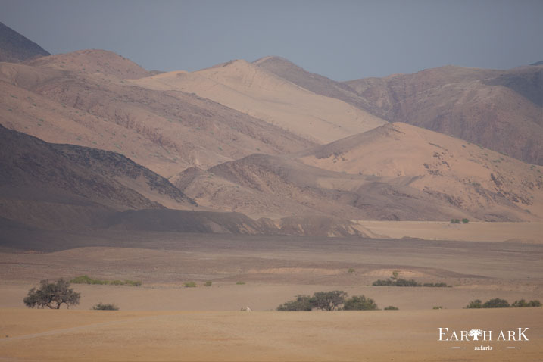
Price includes the following:

- Accommodation as stated above on a twin sharing basis (subject to availability).
- Transportation in a luxury air-conditioned safari vehicle, and fuel.
- All meals as stipulated above on a Breakfast, Lunch, Dinner basis (BLD)
- Services of a registered and experienced English-speaking safari guide.
- All entrance fees and guided excursions as described in above itinerary.
- Return airport transfers from and to Windhoek International Airport.
- Mineral water on board the safari vehicle.
- Meet and greet on arrival and safari welcome pack.

Price excludes the following:
- International flights to Namibia and airport taxes.
- Any entrance fees and guided excursions not included in the above itinerary.
- All beverages with the exception of mineral water on board the safari vehicle.
- Laundry service.
- Gratuities.
- Items of personal nature (telephone expenses, curios, medicines etc).
- ENTRY VISA FEES.
- BANK CHARGES (as per bank or 3.5% commission for VISA/MASTER and 4.5% commission for AMEX).
- Tour Leader fees if you’d like to be accompanied by a representative of Earth Ark Safaris.
- Sossusvlei Extension (paid Separately)

Please Note:
Services are subject to availability at the time of booking.
Rates are subject to change without prior notice due to circumstances beyond our control eg: fuel increases, currency fluctuations.
Terms & Conditions apply.

All you need to know
Flights to and from Windhoek, Namibia.
There are daily flights from Johannesburg (OR Tambo) Airport to Windhoek. The flight is approximately 2 hours long.

Wildlife and game viewing:
Most of your experience will be in a Land Cruiser game viewer. Wildlife viewing and photography requires huge amounts of time and patience as well as stamina in the deserts of Namibia. Some of days you will be giving a picnic lunch from the lodge so bring a backpack!
It is highly recommended to invest in a good pair of binoculars. The Nikon Monarch 10 x 42 is great value. We will be spending many hours each day watching and photographing wildlife. I decent DSLR is recommended with a wide-angle lens and a zoom lens. More advice on cameras is available by emailing Steve at steve@eartharkbotswana.com

Although there are no guarentees as to what wildlife you’ll see in Naimbias vast deserts ther is of course the promise of some of the most dramatic landscapes in Africa, even from the comfort of your lodge room…

Depending on your group size, all transfers between lodges and parks will be in one or two 4x4 fully air conditioned Land cruisers, each with your own English-speaking guide.

Health and Fitness
No vaccinations are mandatory but please consult your doctor for medical advice. Parts of Namibia are considered to be malarial so we recommend the use of anti-malarial prophylactics (normally Malarone), especially if visiting during the Namibian summer (December to April) – subject to advice from your own doctor.

Visas
Please ensure: 1) that you have pre-arranged your entry visa if required; 2) that your passport is valid for at least six months after your scheduled departure date from Namibia; 3) that you have a minimum of 2 consecutive clear pages. If this is not the case, there is a danger of being turned away by the Immigration Service on arrival at the airport – assuming your airline has agreed to bring you and risk a fine in the first place.

What to pack
Is normally restricted to 20 kg (not including photographic equipment) per person in a soft, hold all type bag. Weight is generally less important than volume as everything is carried with you on safari. If adding extensions that involve light aircraft transfers the luggage limit may be reduced further to 12 kg in soft bags (please enquire if this may apply to you). If required, any extra luggage can be stored at our base when visitors are away on safari.

Information on climate, essentials you’ll need and a check list is all on our “Registration Form” document.

Cancellation Policy
Deposits are 50% per person to confirm booking.
Full payment is required 120 days prior to arrival in Namibia.

Cancellations received will be subject to the following forfeit of only the tour cost
- 91 days and above 50% of the tour cost
- 46-90 days 60% of tour cost
- 31-45 days 80% of tour cost
- 0-30 days 100% of tour cost

A breakdown of all permit fees will be submitted to you subject to cancellation.

Cancellation fees are based on the date your written notification is received, at Earth Ark Safaris, by email.

We as a company are totally dedicated to providing a wildlife photographic experience with an added element of eco travel and community support in Namibia and we look forward to sharing this part of the world with you on safari.

So, what are you waiting for? Fill in your Registration Form and get ready for a trip of a lifetime!

Kind regards

Steven Stockhall

